Installing NVIDIA CUDA Toolkit

Pre-installation:

Please note that the steps are defined assuming a freshly installed Ubuntu 16.04 machine with an NVIDIA GPU. Check the CUDA Toolkit documentation (link given below) in case of different settings.

1. Make sure the system is compatible. Go through sections 1 and 2 mentioned in the CUDA Toolkit documentation (see References for link).

2. Download the .run file from here and save it preferably in the Home directory as it will avoid the need to navigate during installation:

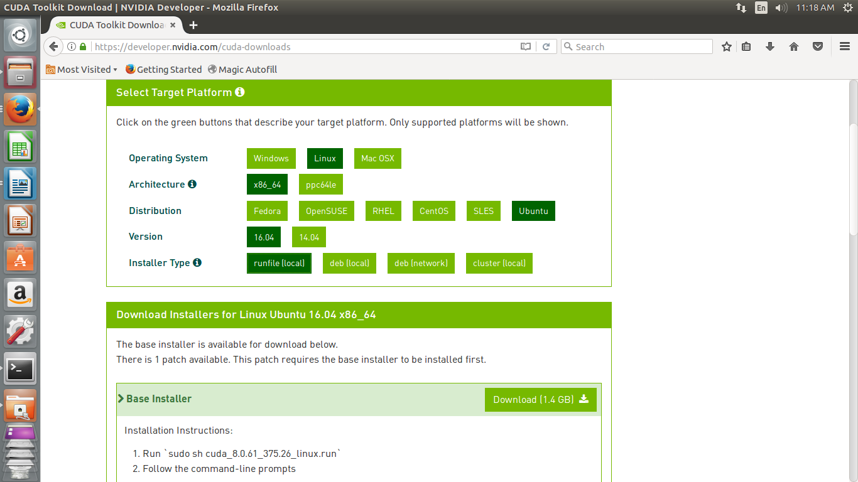

3. Open Terminal and run the below command and restart the Terminal:

>sudo apt-get update

Installation:

1. Before installing the CUDA Toolkit, the default Ubuntu display drivers have to be disabled. To do this,

a. Open a new Terminal window

b. Create a file at /etc/modprobe.d/blacklist-nouveau.conf with the following contents:

blacklist nouveau

options nouveau modeset=0

c. Run the following command

>sudo update-initramfs -u

d. Reboot the system. After the system reboots DO NOT LOGIN.

2. Hit Ctrl+Alt+F1

3. Login with standard user credentials

4. Disable the X server by running:

>sudo service lightdm stop

5. Make the installer executable by running:

>chmod +X <installer file name>.run

6. Run the installer. During the installation accept the default options wherever the installer prompts, with one exception. DO NOT choose install OpenGL libraries.

>sudo ./<installer file name>.run

7. After the installation is complete restart X server by running:

>sudo service lightdm restart

8. Log into the system and reboot the machine to complete the installation of CUDA Toolkit.

Post-installation steps:

1. Set the environment variables of CUDA. To do this, update .bashrc of the current user with the following lines (change location as necessary):

export PATH=/usr/local/cuda-8.0/bin:$PATH

export LD_LIBRARY_PATH=/usr/local/cuda-8.0/lib64

2. Start a new Terminal or load .bashrc (> source .bashrc) to load the updated env variables and run the following commands:

To get the GPU and driver details:

>nvidia-smi

To check the version of NVIDIA CUDA compiler:

>nvcc -V

To get the details of GPU:

>cd ~/NVIDIA_CUDA-8.0_Samples/1_Utilities/

>./deviceQuery

Foot notes:

1. In the Unity dock search for Software and Updates, go to the Updates tab and change the settings as below to disable Updates. It is a common issue that updates break NVIDIA drivers on Ubuntu.

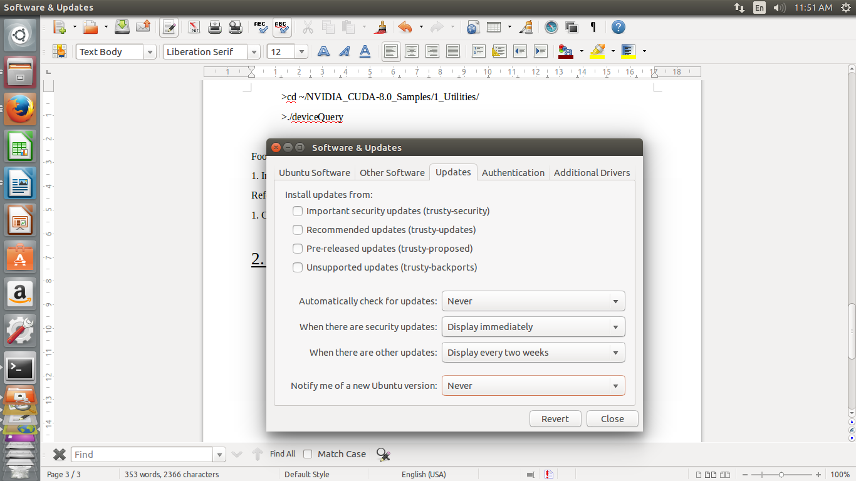

References:

1. CUDA Toolkit Documentation:

docs.nvidia.com/cuda/cuda-installation-guide-linux/index.html

2. Post recommending to not install OpenGL libraries

<https://devtalk.nvidia.com/default/topic/878117/-solved-titan-x-for-cuda-7-5-login-loop-error-ubuntu-14-04-/>